Netflix content analysis

--1. Count the number of Movies vs TV Shows

SELECT type , COUNT(*) AS
category
FROM netflix_titles
GROUP BY type ;

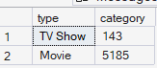
--2. Find the most common rating for movies and TV shows
WITH rate AS (
SELECT
type,
rating,
COUNT(*) AS rating_count
FROM netflix_titles

GROUP BY type, rating
),
rate_rank AS
(
SELECT
type,
rating,
rating_count,
RANK() OVER
(
PARTITION BY type
ORDER BY rating_count DESC
)AS rn
FROM rate
)
SELECT
type,
rating,
rating_count
FROM rate_rank
WHERE rn =1;

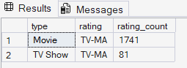
--List all movies released in a specific year (e.g., 2020)

SELECT release_year , COUNT(*) AS movies_released
FROM netflix_titles
WHERE type ='movie'
GROUP BY release_year
HAVING release_year = 2020;

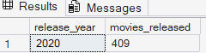

--Find the top 5 countries with the most content on Netflix

SELECT TOP 5 country,
COUNT(*) AS total_content
FROM netflix_titles
GROUP BY country
ORDER BY total_content DESC ;

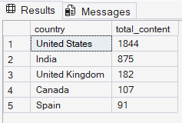
--6. Find content added in the last 5 years

SELECT
type,
title,
date_added
FROM
netflix_titles
WHERE YEAR(date_added) BETWEEN 2017 AND 2021
ORDER BY YEAR(date_added) DESC ;

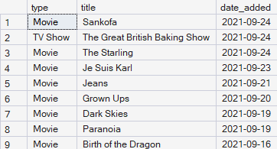

-- Find all the movies/TV shows by director 'Rajiv Chilaka'
SELECT title,director
FROM netflix_titles
WHERE director='Rajiv chilaka';

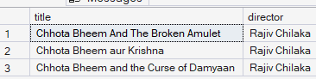
-- 8. List all TV shows with more than 5 seasons

SELECT
type,
title,

CAST(LEFT(duration,CHARINDEX(' ',duration) -1) AS INT)AS season
FROM netflix_titles
WHERE type = 'TV Show'
AND CAST(LEFT(duration,CHARINDEX(' ',duration) -1) AS INT)>5
ORDER BY season DESC;

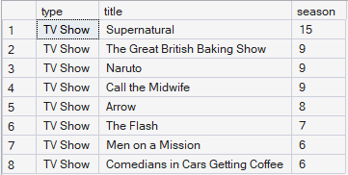
--9. Count the number of content items in each genre

SELECT listed_in ,COUNT (*)AS content
FROM netflix_titles
GROUP BY listed_in;

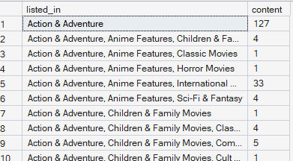

--12. Find all content without a director
SELECT
* FROM
netflix_titles
WHERE director IS NULL ;

--10.Find each year and the average numbers of content release in India on Netflix, return top 5 year with highest avg content release!

WITH cont
AS
(
SELECT
DATEPART(YEAR,date_added) AS year_added ,
COUNT(*) AS content
FROM netflix_titles
GROUP BY DATEPART(YEAR,date_added)
),
avg_cont
AS (
SELECT year_added,
AVG(content) AS avrg_content
FROM cont
GROUP BY year_added
)
SELECT TOP 5
* FROM avg_cont
ORDER BY avrg_content DESC;

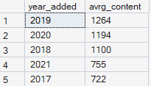
--13. Find how many movies actor 'Salman Khan' appeared in last 10 years!

SELECT
title,
release_year ,
COUNT(*) AS total_movies
FROM netflix_titles
WHERE type ='movie'
AND cast LIKE '%salman khan%'
AND release_year BETWEEN 2011 AND 2021
GROUP BY title,release_year
ORDER BY release_year DESC ;

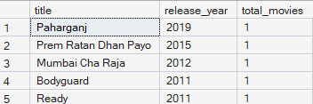

-- select top 5 content genre on the basis of content consumed

SELECT TOP 5 listed_in ,COUNT (*)AS content
FROM netflix_titles
GROUP BY listed_in
ORDER BY content DESC ;

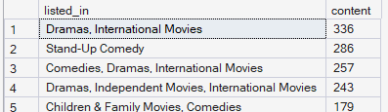
--11. List all movies that are documentaries

SELECT title
FROM netflix_titles
WHERE type LIKE '%movie%' AND listed_in LIKE '%documentaries%' ;

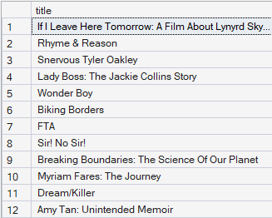
-- Identify the longest movie

SELECT TOP 1
title,
duration
FROM netflix_titles
WHERE type = 'Movie'
ORDER BY CAST(REPLACE(duration, ' min', '') AS INT) DESC;
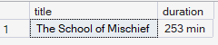
--Categorize the content based on the presence of the keywords 'kill' and 'violence' in
--the description field. Label content containing these keywords as 'Bad' and all other
--content as 'Good'. Count how many items fall into each category.

SELECT
CASE
WHEN description LIKE '%kill%'
OR description LIKE '%violence%'
THEN 'bad'
ELSE 'good'
END AS category ,
COUNT(*) AS total_count
FROM netflix_titles
GROUP BY
CASE
WHEN description LIKE '%kill%'
OR description LIKE '%violence%'
THEN 'bad'
ELSE 'good'
END;

